Attempt 2: Dimension Reduction Methods
Task 2
Kiara Angelys Gänger
Western Governor University
D212 | Data Mining II

Scenario 1
One of the most critical factors in customer relationship management that directly affects a company’s long-term profitability is understanding the customers. When a company understands its customers’ characteristics, it is better able to target products and marketing campaigns for customers, resulting in better profits for the company in the long term.
You are an analyst for a telecommunications company that wants to better understand the characteristics of its customers. You have been asked to use principal component analysis (PCA) to analyze customer data to identify the principal variables of your customers, ultimately enabling better business and strategic decision-making.

Part I: Research Question

Purpose of Report

Question
How can we identify the key characteristics of telecommunications customers that contribute most to customer churn and service usage patterns?

Goal
My goal is to use PCA to reduce the dimensionality of the customer data by identifying the most significant features that explain customer churn and service usage. By focusing on these principal components, I can provide the company with better target marketing ideas and service offerings for the key customer segments.

Part II: Method Justification

Reasons for PCA

Explain how PCA analyzes the data:
Principal Component Analysis (PCA) is a technique that helps simplify complex data by transforming the original variables into a set of new, uncorrelated components called principal components. These components are shorted by how much variance in the data they capture. The idea is to reduce the dataset’s complexity while keeping as much of the underlying structure as possible (Principal Component Analysis (PCA) Explained | Built In, 2024). The best way to look at it is to think of a musical orchestra with over 20 instruments and finding the 6 that can create the same music without all the extra noise.
My expected out outcome by running PCA on the churn dataset, I am hoping to identify the most important patterns and relationships between variables like tenure, monthly charges, and service usage. The expectation is that PCA will highlight the key drivers behind customer behavior, helping the company focus on the factors that matter most for decision-making. The goal here is to cut out the noise and give me a clearer understanding of customer segments and trends.

Assumption of PCA :
One assumption of PCA is that the data has to be linear. PCA looks for directions where the data has the most variance, and this works best if relationships between variables is linear. If the data has non-linear relationships, PCA might miss capturing these patterns. So, before applying PCA, it’s important to check if this assumption holds true for the dataset, or if some preprocessing is needed.

Part III: Data Preparation

Perform Data Preparation

Identify Initial Variables
After removing Yearly_equip_failure and reviewing the rest of the variables choosen. The best variables to answer my question are:
MonthlyCharge (continuous) | Tenure (continuous) | Bandwidth_GB_Year (continuous)
Outage_sec_perweek (continuous) | Income (continuous)
These variables were chosen because they are continuous variables that can hopefully reveal patterns related to customer behavior, service reliability, and financial status.

Standardization
To standardize this dataset, I loaded the churn data then pulled the variables I will be using for this analysis. I then performed the following code for standardization: (Bobbitt, 2020)
1. churn <- read.csv("C:/Users/Kiara/OneDrive/WGU MSDA/D212 Data Mining II/churn_clean.csv")
2. View(churn)
3.
4. # Select the continuous variables
5. continuous_vars <- churn[, c(
6. "Tenure",
7. "MonthlyCharge",
8. "Bandwidth_GB_Year",
9. "Outage_sec_perweek",
10. "Income"
11. )]
12.
13. # Standardize the continuous variables
14. standardized_data <- scale(continuous_vars)
15.
16. # View the standardized data
17. head(standardized_data)
18.
19. write.csv(
20. standardized_data,
21. "C:/Users/Kiara/OneDrive/WGU MSDA/D212 Data Mining II/Task 2/standardized_data.csv",
22. row.names = FALSE
23. )
The clean dataset is attached to the submission as standardized_data
Fist 6 rows of standardized dataset for the 5 variables chosen:
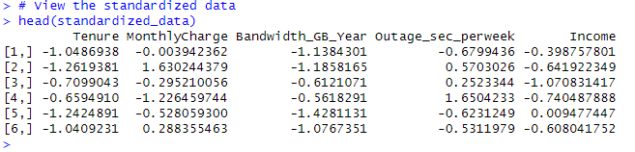
By standardizing the data, I can ensure that all variables are on the same scale. This is super important for PCA as it treats all dimensions equally during the analysis.

Part IV: Analysis

Perform PCA

Determine the Matrix
To determine the matrix of principal components, I ran the following PCA code on the standardized dataset (Bobbitt, 2020)
# Perform PCA on standardized data
pca_result <- prcomp(standardized_data, center = TRUE, scale. = TRUE)
# View the matrix of principal components
pca_result$x # This will give the principal component scores for each observation
Preview of output:
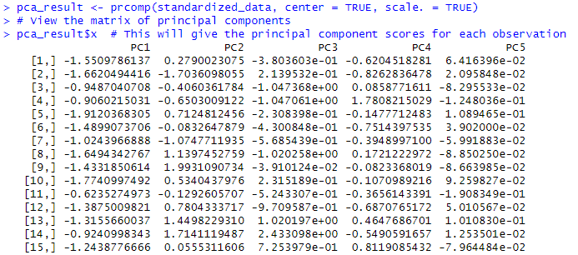
PC1 | PC2 | PC3 | PC4 | PC5
Tenure | MonthlyCharge | Bandwidth_GB_Year | Outage_sec_perweek | Income
The matrix of principal components shows the transformed dataset in a new setup where the components don’t overlap, and they point in the directions with the most variance. It’s like rearranging the data to make the most of the patterns.

Number of Principal Components
To determine the total number of principal components I will use a scree plot. This will show me an elbow chart and I can retain the components where the plot levels off. (Bobbitt, 2020)
# Generate scree plot
screeplot(pca_result, type = "lines", main = "Scree Plot")
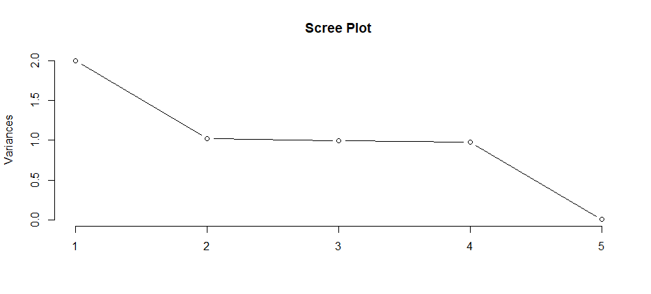
Based on the plot I can see that two principal components capture most of the variance, and the rest do not add much. This tells me that by using just these two components, I can reduce the complexity without losing a lot of information.

Identify the variance:
(Bobbitt, 2020)
1. # Variance explained by the principal component selected in D2
2. explained_variance_first_two <- summary(pca_result)$importance[2, 1:2]
3. explained_variance_first_two
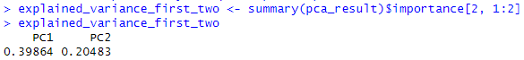
The variances explained by each of the principal components:
- PC1 Tenure: 39.864%
- PC2 MonthlyCharge: 20.483%
The outcome shows that Tenure or PC1 has the highest portion of variance, followed by MonthlyCharge or PC2

Identify the total variance:
To calculate the total variance captured I used the following code (Bobbitt, 2020)
# Calculate the total variance captured by the first two components
total_variance_first_two <- sum(explained_variance_first_two)
total_variance_first_two

- Total Variance: 60.347%

Summary of PCA analysis:
After standardizing the data, running the matrix, plot and PCA I have found that with the plot I can see that after number 2 the line starts to flatten out. This is an indication that that anything before PC3 can sufficiently explain the majority of the variance in the data. PC1 explains 39.864% of the total variance and PC2 explains 20.483%. Just those two combined captures about a total of 60.347% of total variance in the dataset. In simple terms tenures plays the biggest role in the dataset’s variability and monthly charge comes in second. With just these two components I get a simplified but meaningful view of the customer data, making it easier to spot trends that could help with visualizations and to analyze relationships in the data and provide insight on marketing and service improvements.

Part V: Attachments

Panopto Video

Link: Ganger, Kiara Task 2 D212 Take 2

References
Bobbitt, Z. (2020, December 1). Principal Components Analysis in R: Step-by-Step Example. Retrieved from STATOLOGY: https://www.statology.org/principal-components-analysis-in-r/
Principal Component Analysis (PCA) Explained | Built In. (2024, September 10). Retrieved from geeksforgeeks: https://builtin.com/data-science/step-step-explanation-principal-component-analysis

